News from CPSC

U.S. Consumer Product Safety Commission
Office of Information and Public Affairs Washington, D.C. 20207

For Immediate Release Firm’s Recall Hotline: (888) 597-6597
August 14, 2007 CPSC Recall Hotline: (800) 638-2772
Release #07-273 CPSC Media Contact: (301) 504-7908

Additional Reports of Magnets Detaching from Polly Pocket Play Sets Prompts Expanded Recall by Mattel

WASHINGTON, D.C. – The U.S. Consumer Product Safety Commission, in cooperation with the firm named below, today announced a voluntary recall of the following component of a consumer product. Consumers should stop using recalled products immediately unless otherwise instructed. (To access color photos of the following recalled products, see CPSC’s Web site at www.cpsc.gov.)

Name of Products: Various Polly Pocket dolls and accessories with magnets
Units: About 7.3 million play sets (about 2.4 million play sets were recalled on November 21, 2006)
Importer: Mattel Inc., of El Segundo, Calif.
Hazard: Small magnets inside the dolls and accessories can come loose. The magnets can be found by young children and swallowed or aspirated. If more than one magnet is swallowed, the magnets can attract each other and cause intestinal perforation or blockage, which can be fatal.
Incidents/Injuries: Since the previous recall announcement, Mattel has received more than 400 additional reports of magnets coming loose. CPSC was aware in the first recall announcement of 170 reports of the magnets coming out of the recalled toys. There had been three reports of serious injuries to children who swallowed more than one magnet. All three suffered intestinal perforations that required surgery.
Description: The recalled Polly Pocket play sets contain plastic dolls and accessories that have small magnets. The magnets measure 1/8 inch in diameter and are embedded in the hands and feet of some dolls, and in the plastic clothing, hairpieces and other accessories to help the pieces attach to the doll or to the doll’s house. The model number is printed on the bottom of the largest pieces on some of the play sets. Products manufactured after November 1, 2006 and are currently on store shelves are not included in this recall. Contact Mattel if you cannot find a model number on your product to determine if it is part of the recall.
Sold at: Toy stores and various other retailers from May 2003 through November 2006 for between $15 and $30.
Manufactured in: China
Remedy: Consumers should immediately take these recalled toys away from children and contact Mattel to receive a voucher for a replacement toy of the customer’s choice, up to the value of the returned product.
Consumer Contact: For additional information, call Mattel toll-free at (888) 597-6597 anytime, or visit the firm’s Web site at www.service.mattel.com.

Polly Pocket Magnetic Play Sets | Item Number | Photo
Polly Pocket!™ Polly Place™ Hangin’ Out House™ | B2632 | 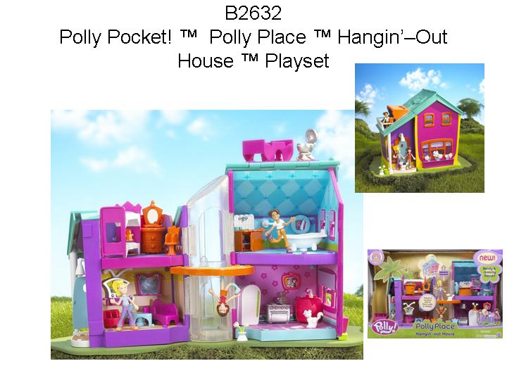
Polly Pocket!™ Polly Place™ Treetop Clubhouse™ | B3158 | 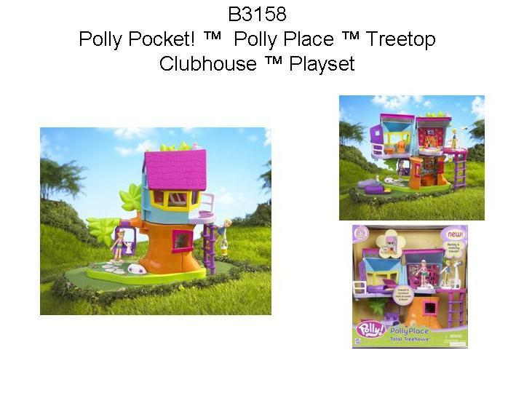
Polly Pocket!™ Spa Day™ | B3201 | Picture not available
Polly Totally!™ Polly Place™ Totally Tiki Diner™ | B7118 | 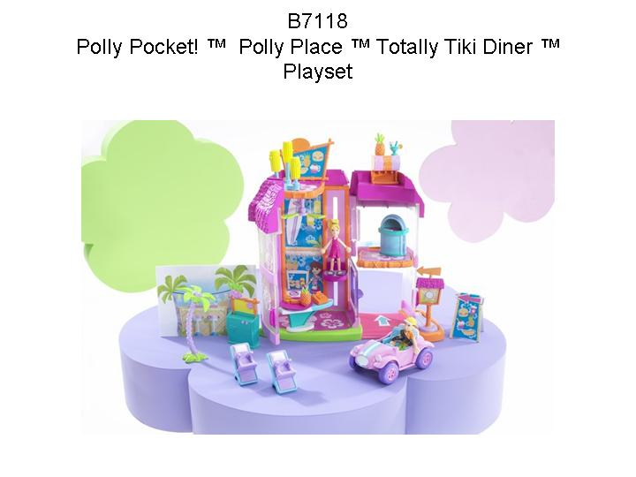
Polly Pocket!™ Quik-Clik™ Boutique | G8605 | Picture not available
Polly Pocket!™ Quik-Clik™ City Pretty Playset | H1537 | 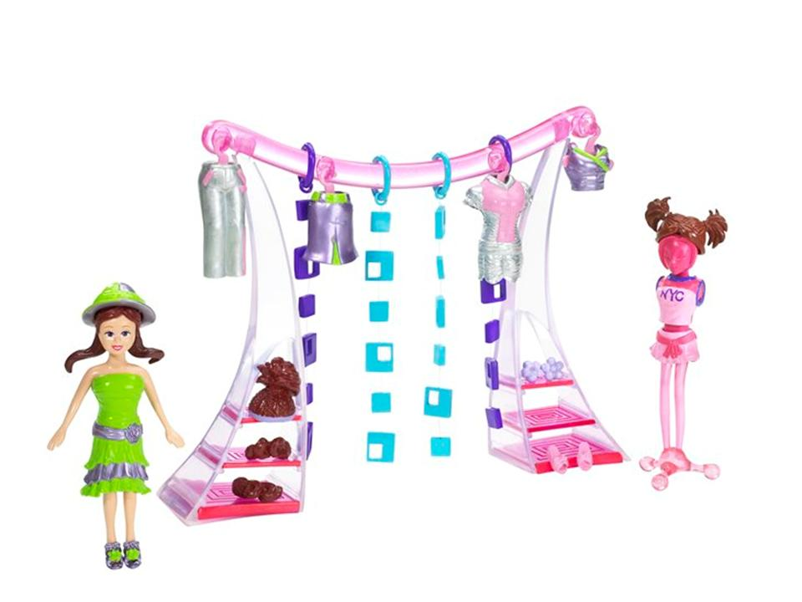
Polly Pocket!™ Quik-Clik™ Sporty Style Playset | H1538 | 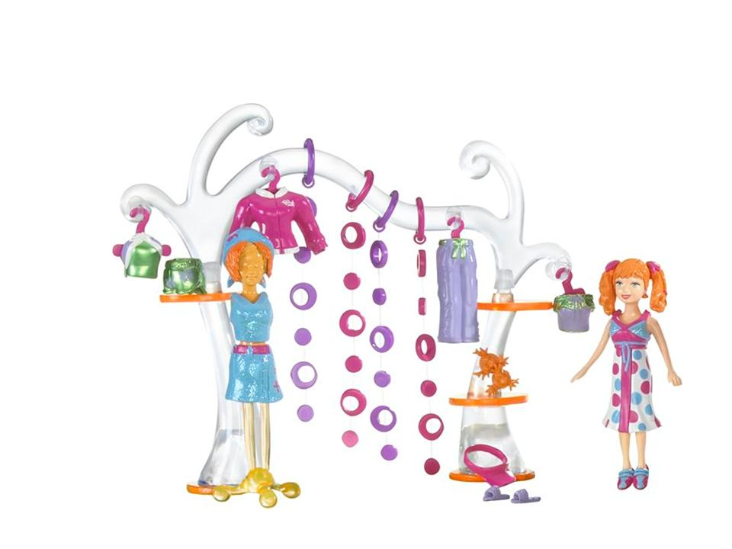
Polly Pocket!™ Totally Zen™ Playset | H3211 | 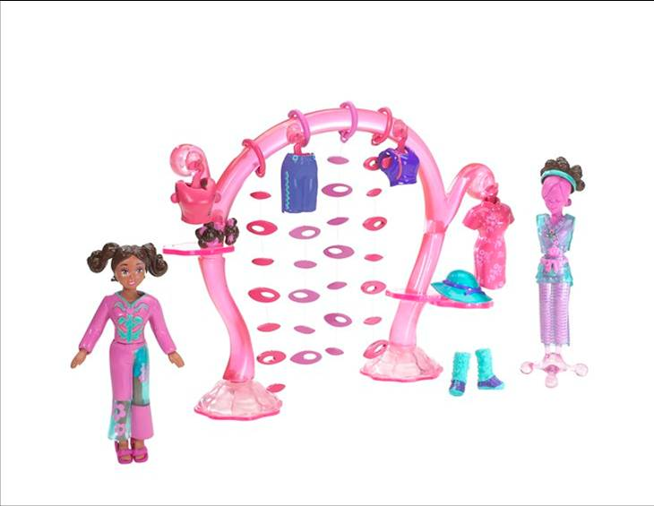
Polly Pocket!™ Happenin’ Pet Station | 55503 | 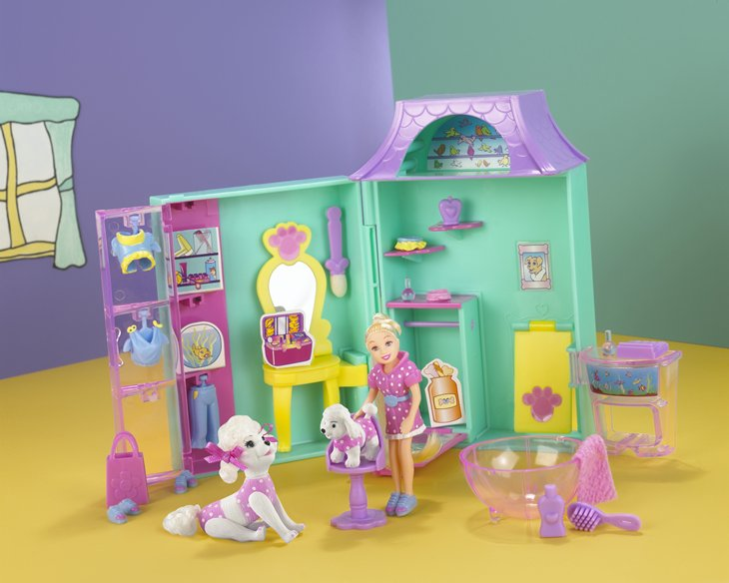
Polly Pocket!™ Polly Place™ Magnetic Additions Assortment | B2631 | Picture not available
Polly Pocket!™ Activity Lunchbox | B3203 | Picture not available
Polly Pocket!™ Activity Locker | B3204 | Picture not available
Polly Pocket!™ Collectible Lip Gloss | B3207 | Picture not available
Polly Pocket!™ Collectible Make Up Powder Puff | B3209 | Picture not available
Polly Pocket!™ Dip N’ Dive Pool | B3210 | Picture not available
Polly Pocket!™ Birthday Surprise | B3396 | Picture not available
Polly Pocket!™ Dazzlin’ Pet Show™ Divine Dogs | B7078 | Picture not available
Polly Pocket!™ Rick’s Magic Show | B7082 | Picture not available
Polly Pocket!™ Sweet Treats | B7125 | Picture not available
Polly Pocket!™ Birthday Mailbox | B7127 | Picture not available
Polly Pocket!™ Stretch Polly Disco Lamp | B7128 | Picture not available
Polly Pocket!™ Jewelry Box Purple | B7129 | Picture not available
Polly Pocket!™ Polly Magnet Bus | B8478 | Picture not available
Polly Pocket!™ Collectible Caboodle | B9521 | Picture not available
Polly Pocket!™ Activity Lunch Box Pink | B9522 | Picture not available
Polly Pocket!™ Activity Locker Orange | B9523 | Picture not available
Polly Pocket!™ Polly Glitter Puff | B9525 | Picture not available
Polly Pocket!™ Collectible Caboodle Purple | B9578 | Picture not available
Polly Pocket!™ Fashion Boutique on the Go | B9929 | Picture not available
Polly Pocket!™ Birthday Mailbox Pink | C0504 | Picture not available
Polly Pocket!™ Jewelry Box Yellow | C0505 | Picture not available
Polly Pocket!™ Disco Lamp | C1341 | Picture not available
Polly Pocket!™ Disco Lamp Purple | C1342 | Picture not available
Polly Pocket!™ Mermaid Stars | G8602 | Picture not available
Polly Pocket!™ Quick Click™ Playset | G8606 | Picture not available
Polly Pocket!™ Snow Cool™ Hotel | G8612 | 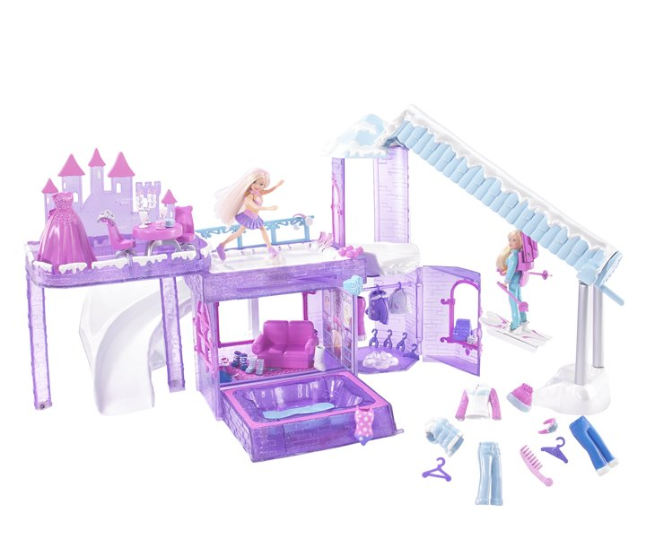
Polly Pocket!™ Quick Click™ House of Style™ Playset | G8614 | 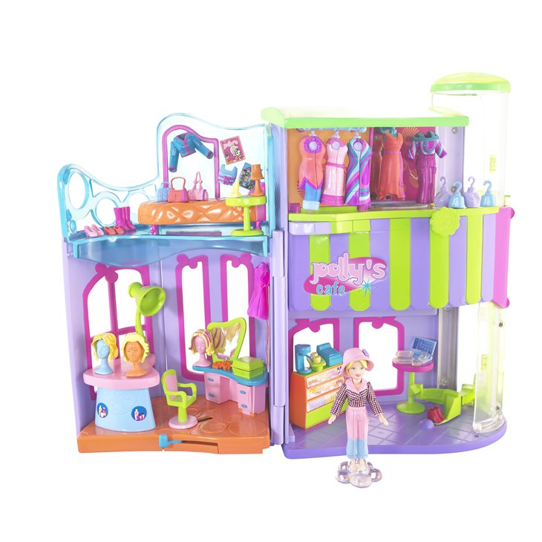
Polly Pocket!™ Polly by Me Totally Beadiful | G8615 | 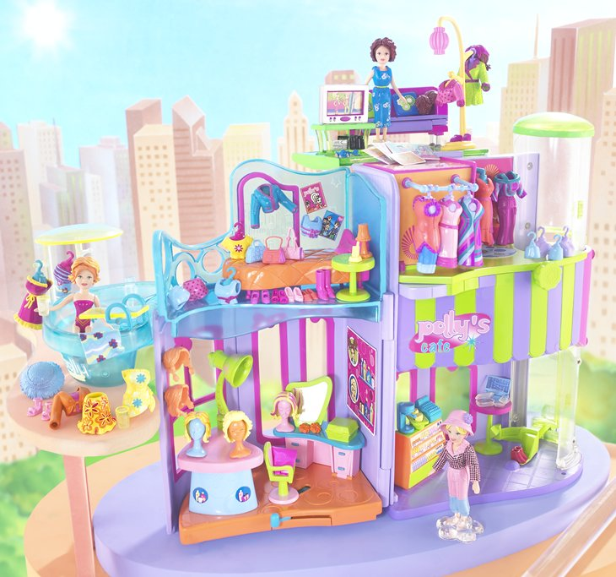
Polly Pocket!™ Quick Click™ Penthouse | G8616 | 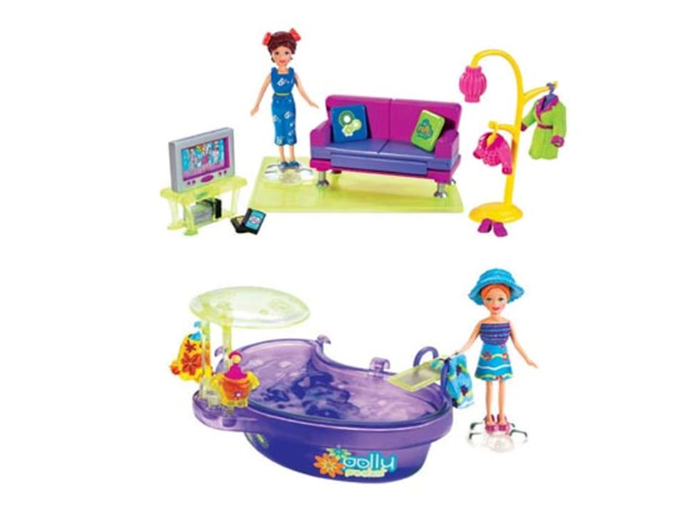
Polly Pocket!™ Quick Click™ Movie Time™ Playset | H1553 | 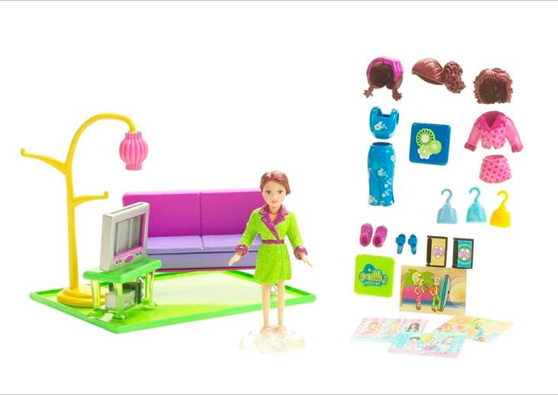
Polly Pocket!™ Pollywood™ Limo-Scene™ Vehicle | J1659 | Picture not available
Polly Pocket!™ Pollywood™ Dial A Style™ Lila | J1661 | 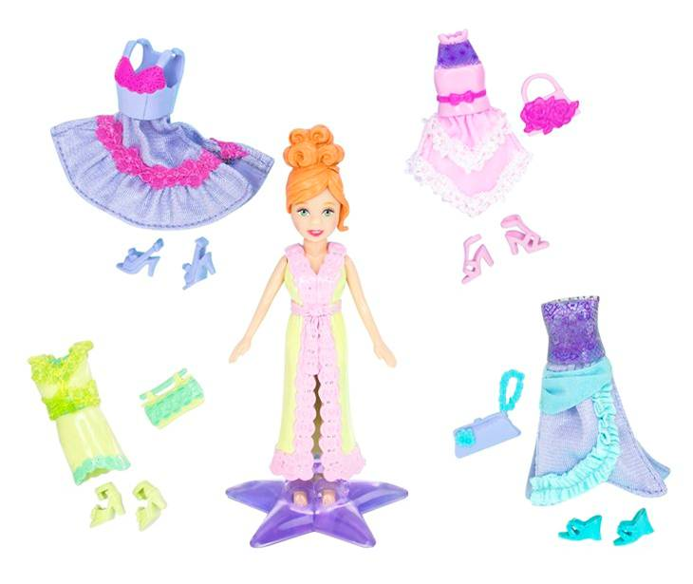
Polly Pocket!™ Pollywood™ Dial A Style™ Lea | J1662 | 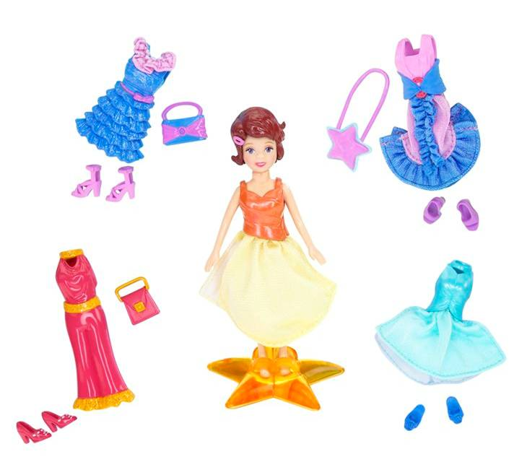
Polly Pocket!™ Stick N’ Style™ | J1670 | Picture not available
Polly Pocket!™ Pollyworld™ Rockin’ Theme Park™ Playset | J1681 | 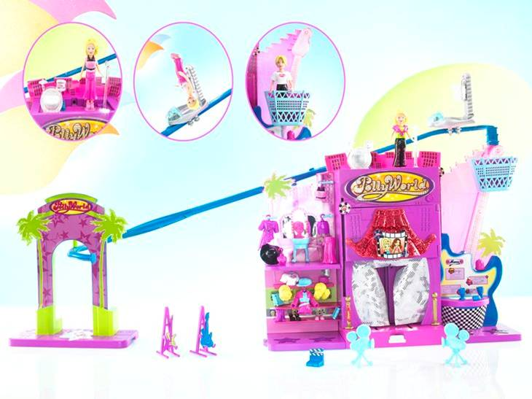
Polly Pocket!™ Pollyworld™ Dress N’ Drive™ Lounge Playset | J1687 | 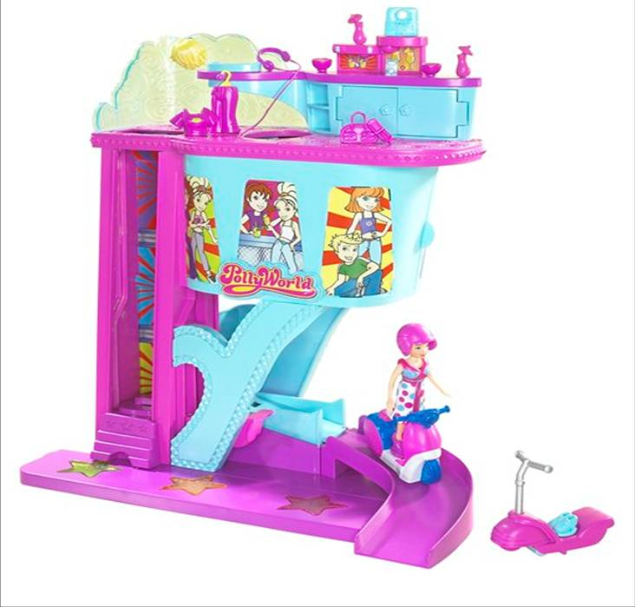
Pollyworld™ Theme Park Party™ Quick Click™ Doll and Fashion | J1695 | 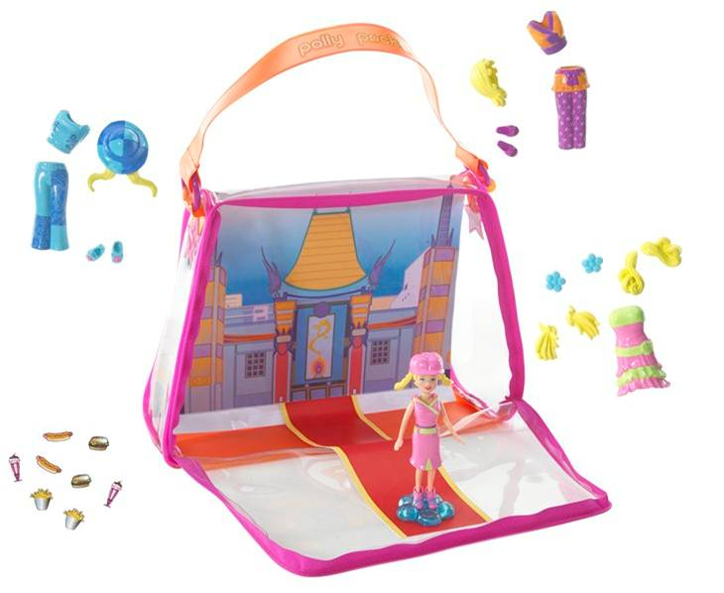
Polly Pocket!™ Pollyworld™ Quick Click™ Polly™ Doll | J4169 | 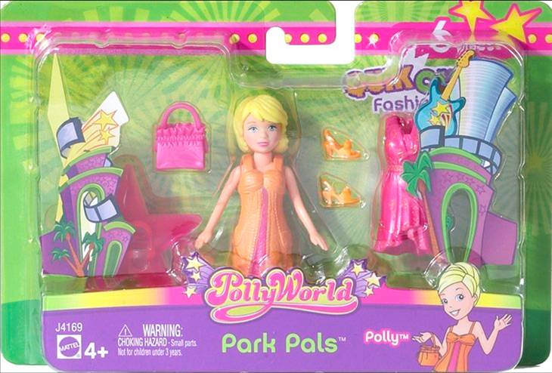
Polly Pocket!™ Pollyworld™ Quick Click™ Crissy™ Doll | J4170 | 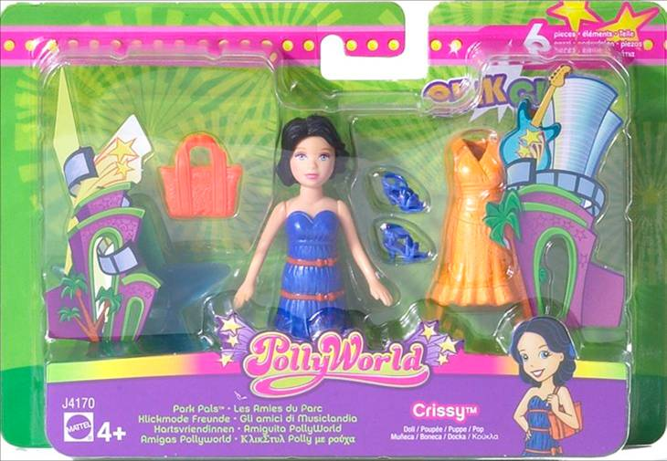
Polly Pocket!™ Pollyworld™ Quick Click™ Lea™ Doll | J4171 | 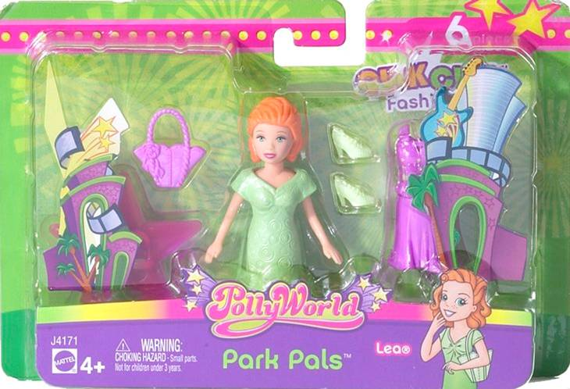
Polly Pocket!™ Pollyworld™ Quick Click™ Shani™ Doll | J4172 | 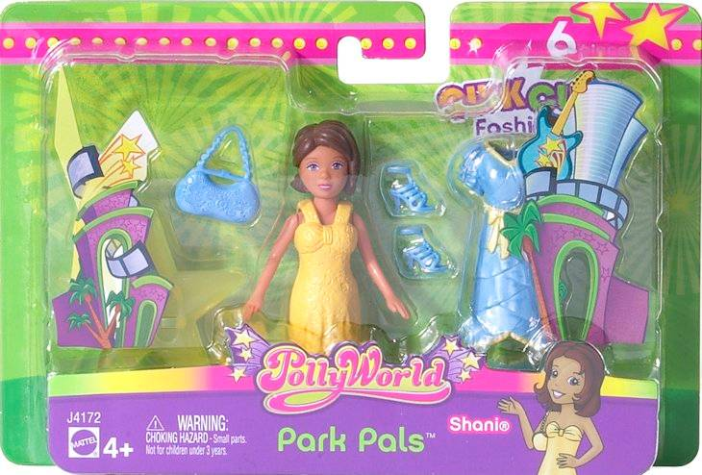
Polly Pocket!™ Pollyworld™ Costume Art Lea | J9305 | 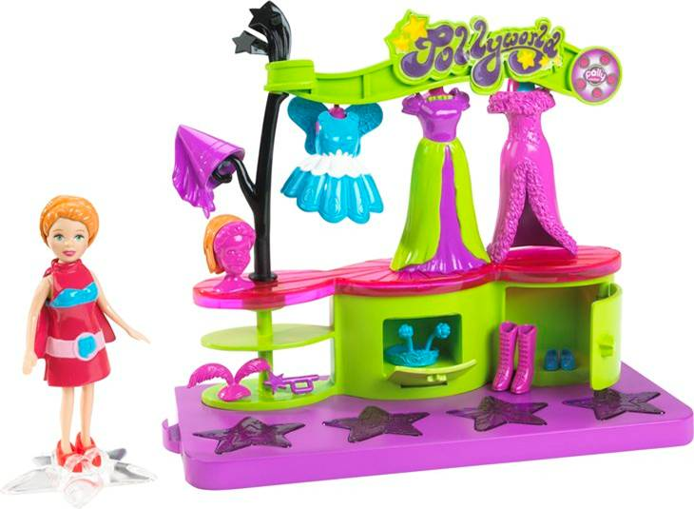
Polly Pocket!™ Pollyworld™ Gift Shop Lila | J9306 | 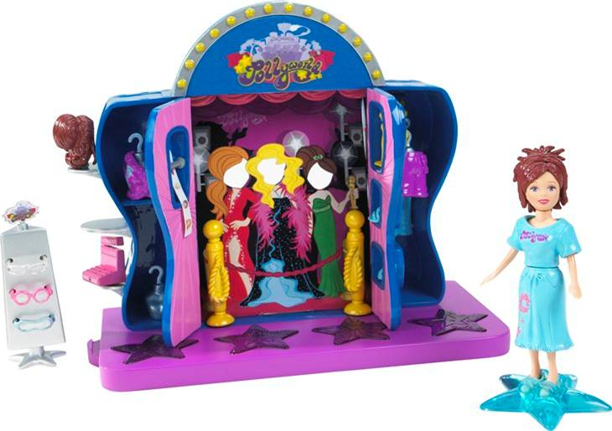
Polly Pocket!™ Twirl and Swirl™ Beauty Case | J9648 | 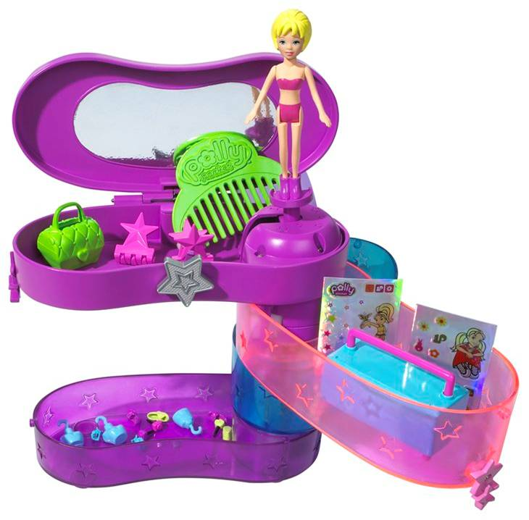
Pollyworld™ Dial a Song Polly Fashions | J9965 | 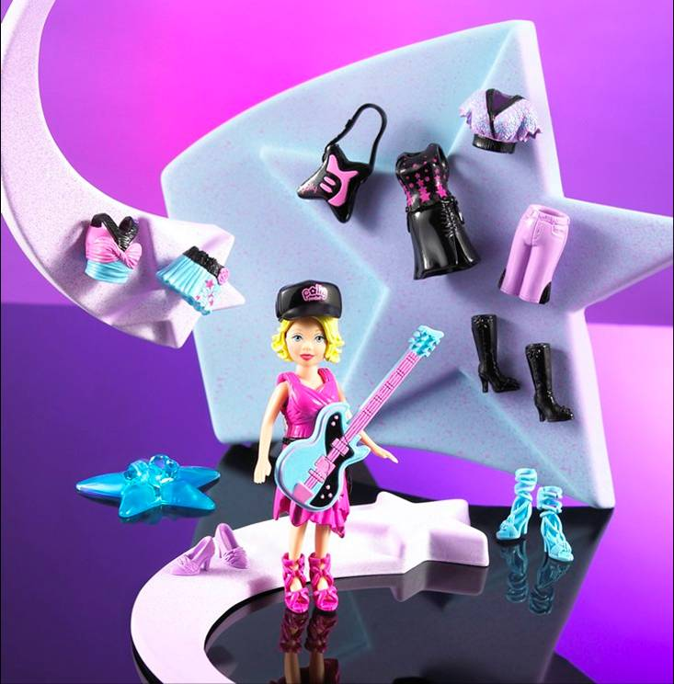
Pollyworld™ Dial a Song Polly Fashions | J9966 | 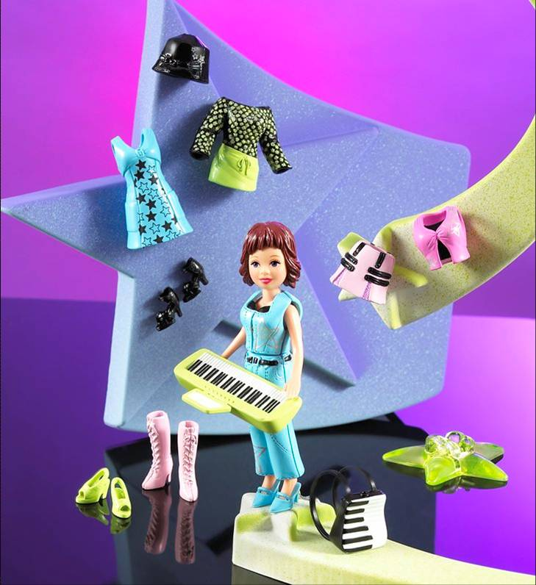
Pollyworld™ Rockin’ Tour Bus | K3460 | 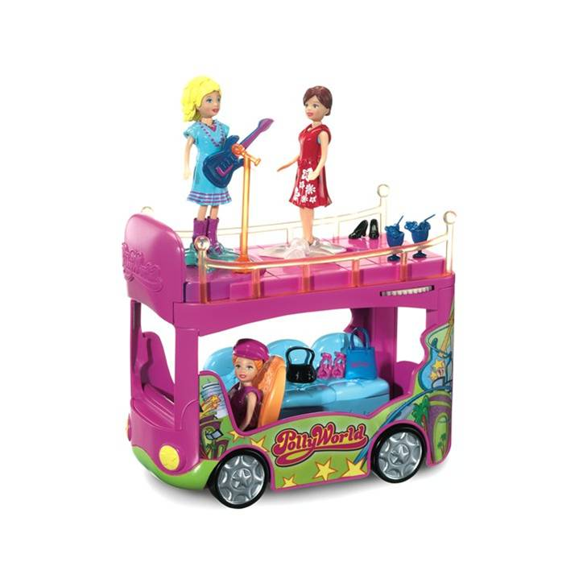
Polly Pocket!™ Quick Click™ Pool Party™ Playset | H1554 | 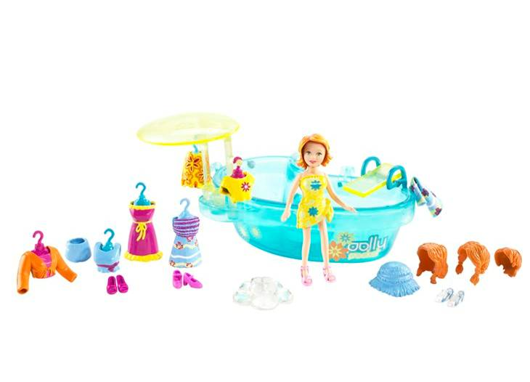

Send the link for this page to a friend! The U.S. Consumer Product Safety Commission is charged with protecting the public from unreasonable risks of serious injury or death from more than 15,000 types of consumer products under the agency's jurisdiction. Deaths, injuries and property damage from consumer product incidents cost the nation more than $700 billion annually. The CPSC is committed to protecting consumers and families from products that pose a fire, electrical, chemical, or mechanical hazard or can injure children. The CPSC's work to ensure the safety of consumer products - such as toys, cribs, power tools, cigarette lighters, and household chemicals - contributed significantly to the 30 percent decline in the rate of deaths and injuries associated with consumer products over the past 30 years.
To report a dangerous product or a product-related injury, call CPSC's hotline at (800) 638-2772 or CPSC's teletypewriter at (800) 638-8270, or visit CPSC's web site at www.cpsc.gov/talk.html. To join a CPSC email subscription list, please go to www.cpsc.gov/cpsclist.aspx. Consumers can obtain this release and recall information at CPSC's Web site at www.cpsc.gov.
####

